***To Brief the Histogram,Skewness & Kurtosis – 26.05.2024***

***ASSIGNMENT***

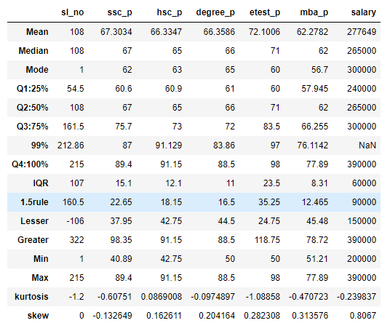

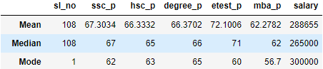

|  |  |  |  |  |  |
| --- | --- | --- | --- | --- | --- |
| Index | Skewness | Kurtosis | Description with relationship | Relationship | Relationship |
| SSC_P | -0.1326494  Skewness<0 | -0.607510 | Negative value  67.3<67<62 | Kurtic<3 | Mean<Median<Mode |
| HSC_P | 0.1626  Skewness>0 | 0.0869 | Positive value  66.3>65>63 | Kurtic<3 | Mean>Median>Mode |
| Degree_P | 0.2041  Skewness>0 | -0.0974 | Positive value  66.3<66<65 | Kurtic<3 | Mean>Median>Mode |
| Etest_P | 0.2823  Skewness>0 | -1.0885 | Positive value  72.1<71<60 | Kurtic<3 | Mean>Median>Mode |
| MBA_P | 0.313 Skewness>0 | -0.4707 | Positive value  62.2>62>56 | Kurtic<3 | Mean>Median>Mode |
| Salary | 0.8067 Skewness>0 | -0.239 | Positive value | Kurtic<3 | Mean>Median>Mode |